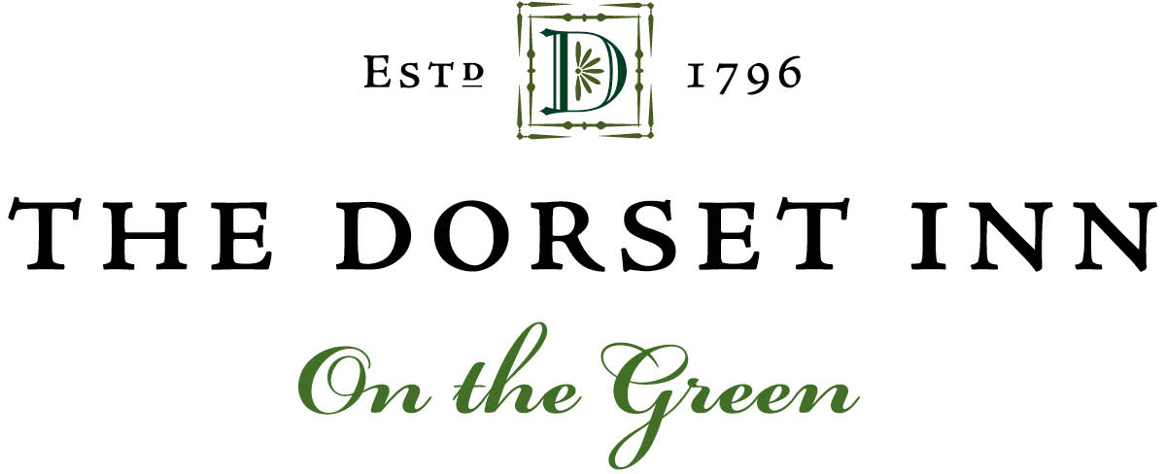
The essence of The Dorset Inn is all about its history ~ the true “Americana.”
The Chef’s menus, recipes and the history of the restaurant bring us back in time, capturing an American spirit celebrated by a cellar focused on American wines. Our domestic wines are categorized by varietal and represent what we believe are among the best of their kind. Our goal is to expand our regional representation taking time to discover the best viticultural offerings across the United States. Having said that, we are more than happy to accommodate the tastes of our regular guests by including wines that are not from our native shores. Please provide your input on our Guest Selections page.

WINES BY THE GLASS

white wines

CHARDONNAY RYAN PATRICK NAKED ~ Columbia Valley WA 2016 11
CHARDONNAY FERRARI CARANO TRE TERRE ~ Russian River Valley CA 2018 15
SAUVIGNON BLANC GREYWACKE ~ Marlborough NZ 2019 12
SAUVIGNON BLANC DAOU VINEYARDS & WINERY ~ Paso Robles CA 2019 13
DRY RIESLING hermann j. wiemer estate ~ Seneca Lake NY 2019 11
pinot Gris rascal ~ Columbia Valley WA 2019 11
Sancerre Lucien Crochet ~ Sancerre FR 2018 15
rosÉ

ROSÉ BONNY DOON VINEYARD Vin Gris de Cigare ~ Central Coast CA 2019 11
red wines

cabernet sauvignon AIRFIELD ~ Yakima Valley WA nv 13
cabernet sauvignon charles krug Yountville ~ Napa Valley CA 2017 15
malbec LA POSTA PIZELLA ~ Mendoza Argentina 2017 11
PINOT NOIR KEN WRIGHT CELLARS ~ Willamette Valley WA 2017 15
pinot noir FRANCIS FORD COPPOLA Director's ~ Sonoma County CA 2017 13
RED BLEND Alexander Valley Homestead ~ Alexander Valley CA 2017 15
sparkling wines

prosecco Caposaldo Brut ~ Italy nv 11
brut Roderer estate ~ Anderson Valley CA nv 13

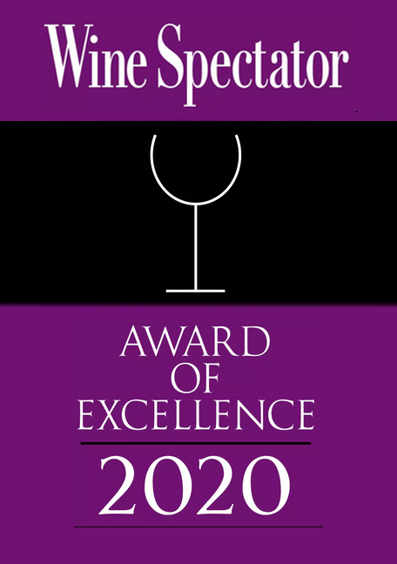
Wine Spectator Award of Excellence

SPARKLING WINES

1 MUMM NAPA Brut Prestige ~ Napa Valley CA nv 46
2 ARGYLE Vintage Brut ~ Willamette Valley OR 2014 55
3 ROEDERER L'Ermitage Brut ~ Anderson Valley CA 2009 105
5 GRUET WINERY Blanc de Noirs ~ Albuquerque NM nv 31
7 PUTNEY MOUNTAIN Putney Bubbly / Sparkling Apple Cider / Non-Alcoholic ~ Vermont nv 29
10 DOMAINE CHANDON Brut ~ California nv 52
11 SCHRAMSBERG VINEYARDS Mirabelle ~ North Coast CA nv 75
12 GLORIA FERRER Brut ~ Sonoma CA nv 40
See Our Imported Selections For French Champagnes

WHITE VARIETALS

SAUVIGNON BLANC

21 FERRARI-CARANO ~ North Coast CA 2019 33
22 Cakebread Cellars ~ Napa Valley CA 2019 58
23 Stag’s Leap Aveta ~ Napa Valley CA 2017 46
24 DAOU VINEYARDS & WINERY ~ Paso Robles CA 2019 46
25 Frog’s Leap ~ Napa Valley CA 2018 40
27 Merry Edwards ~ Russian River Valley CA 2017 71
28 Honig Vineyard & Winery ~ Napa Valley CA 2019 34
30 Rodney Strong Vineyards Charlotte’s Home ~ Sonoma County CA 2018 /2019 30
CHARDONNAY

46 Kistler Les Noisetiers ~ Sonoma Coast CA 2018 110
47 Far Niente Estate ~ Napa Valley CA 2018 110
48 Cakebread Cellars ~ Napa Valley CA 2018 71
49 Mer Soleil Silver / Unoaked ~ Monterey County CA 2017 62
50 Trefethen Estate ~ Oak Knoll District Napa Valley CA 2017 60
51 La Crema ~ Sonoma Coast CA 2017 HALF 21 /41
52 Groth Hillview Vineyard ~ Napa Valley CA 2015 60
53 Cambria estate winery Katherine's Vineyard ~ Santa Maria Valley CA 2017 46
54 Chateau Ste. Michelle ~ Horse Heaven Hills WA 2016 44
55 Sonoma-Cutrer ~ Sonoma Coast CA 2018 HALF 22 /43
56 Rombauer Vineyards ~ Carneros CA 2018 59
57 Ramey wine cellars Fort Ross / Seaview~ Sonoma Coast CA 2016 75
58 RYAN PATRICK NAKED ~ Columbia Valley WA 2016 44
59 FERRARI CARANO TRE TERRE ~ Russian River Valley CA 2018 60
60 Acrobat Winery ~ Oregon 2016 33
61 Kendall-Jackson Vintner’s Reserve ~ California 2018 36
62 Clos Pegase Estate Grown Mitsuko's Vineyard ~ Carneros CA 2017 52
63 Foxglove Un-Oaked ~ Central Coast CA 2017 41
64 Chateau Montelena ~ Napa Valley CA 2016 76
CHARDONNAY~ Continued

67 Chalk Hill Estate ~ Russian River Valley CA 2016 81
70 Shooting Star ~ Mendocino County CA 2016 31
72 Truchard Carneros ~ Napa Valley CA 2016/2018 46
73 Radio-Coteau Wingtine ~ Sonoma Coast CA 2015/2016 98
75 Decoy ~ Sonoma County CA 2018 36
76 Nielson ~ Santa Barbara County CA 2017 34
PINOT GRIS AND PINOT GRIGIO

98 Owen Roe Eola / Crawford-Beck Vineyard ~ Amity Hills WA 2019 36
99 King Estate Winery ~ Willamette Valley OR 2018 42
100 Chateau Ste Michelle ~ Columbia Valley WA 2018 30
101 rascal ~ Columbia Valley WA 2019 44
102 Duckpond ~ Willamette Valley OR 2018 44
103 Erath Winery ~ Oregon 2017 40
104 Elk Cove Vineyards Estate ~ Willamette Valley OR 2018 35
RIESLING AND GERWURTZTRAMINER

121 Chateau Ste Michelle Eroica Riesling ~ Columbia Valley WA 2015 44
122 Trefethen Dry Riesling ~ Oak Knoll District Napa Valley CA 2016 45
123 Red Tail Ridge Good Karma Dry Riesling ~ Finger Lakes NY 2017 33
124 hermann j. wiemer estate ~ Seneca Lake NY 2019 44
125 Boundary Breaks Vineyard Dry Riesling ~ Finger Lakes NY 2014 34
126 Thomas Fogarty Gewürztraminer ~ Monterey County CA 2016 35
127 Navarro Vineyards Gewürztraminer ~ Mendocino CA 2017 40
130 Montinore Estate Almost Dry Riesling ~ Willamette Valley OR 2018 32
OTHER WHITES

145 Shelburne Vineyard Louise Swenson Dry ~ Vermont 2018 35
146 Patton Valley Vineyard Mora Brothers Vineyard Pinot Blanc ~ Willamette Valley OR 2015 40
150 TABLAS CREEK Cotes De Tablas Blanc ~ Adelaida District CA 2016 46
151 TRUCHARD Roussane Carneros ~ Napa Valley CA 2016 36
154 BOYDEN VALLEY WINERY Seyval Blanc ~ Cambridge VT nv 39
156 FESS PARKER WINERY Marcella’s White Blend ~ Santa Barbara County CA 2016 35
158 UPROOT WINES Grenache Blanc ~ Santa Ynez Valley CA 2013 31
159 PINE RIDGE VINEYARDS Chenin Blanc + Viognier ~ Napa Valley CA 2013 36
ROSÉ

171 BONNY DOON VINEYARD Vin Gris de Cigare ~ Central Coast CA 2019 44
172 RYAN PATRICK Rosé ~ Columbia Valley WA 2019 39
173 RODNEY STRONG Rosé of Pinot Noir ~ Russian River Valley CA 2018 31
See Our Import Selections For French Rosé

RED VARIETALS

PINOT NOIR

191 FRANCIS FORD COPPOLA WINERY Director's ~ Sonoma County CA 2017 32
192 PATRICIA GREEN CELLARS Estate Vineyard ~ Ribbon Ridge OR 2018 59
194 REX HILL Willamette Valley ~ Willamette Valley OR 2017 56
195 MERRY EDWARDS Russian River Valley ~ Sonoma County CA 2017 98
196 KEN WRIGHT CELLARS ~ Willamette Valley OR 2018 85
197 THOMAS FOGARTY ~ Santa Cruz Mountains CA 2014 60
198 Archery Summit Dundee Hills ~ Willamette Valley OR 2018 90
199 Cambria estate winery Julia's Vineyard ~ Santa Maria Valley CA 2015 48
200 Rodney Strong Vineyards Russian RiverValley ~ Sonoma County CA 2016 40
203 The Four Graces ~ Willamette Valley OR 2018 51
204 Kenwood ~ Russian River Valley 2016 34
206 Truchard Carneros ~ Napa Valley CA 2017 55
208 Belle Glos Clark & Telephone ~ Santa Maria Valley CA 2018 93
210 King Estate ~ Willamette Valley OR 2017 53
211 Point North ~ Willamette Valley OR 2017 48
212 Schug Winery ~ Sonoma Coast CA 2017 52
213 Lincourt Rancho Santa Rosa ~ Santa Rita Hills CA 2017 45
215 Montinore Estate ~ Willamette Valley OR 2017 36
216 Beaux Freres ~ Willamette Valley OR 2017 98
217 OWEN ROE Rocks of Bawn ~ Yamhill-Carlton OR 2018 tbd
MERLOT

241 Duckhorn Vineyards ~ Napa Valley CA 2016 /2017 89
242 Schug winery ~ Sonoma Valley CA 2014 56
244 Swanson Vineyards ~ Napa Valley CA 2017 52
245 Whitehall Lane ~ Napa Valley CA 2015 50
248 Freemark Abbey Winery ~ Napa Valley CA 2014 /2015 65
251 Trig Point Diamond Dust Vineyard ~ Alexander Valley CA 2017 33
252 Alexandria Nicole Gravity ~ Horse Heaven Hills WA 2015 53
253 Frog’s Leap Rutherford ~ Napa Valley CA 2016 / 2017 67
255 Chateau Ste Michelle Indian Wells ~ Columbia Valley WA 2016 37
256 Textbook Vineyards ~ Napa Valley CA 2017 /2018 43
257 Cakebread Cellars ~ Napa Valley CA 2016 100
263 Trefethen Family Vineyards ~ Oak Knoll District Napa Valley CA 2016 / 2017 71
264 charles krug winery ~ Napa Valley CA 2016 100
cabernet sauvignon

291 Rothschild-Mondavi Opus One ~ Napa Valley CA 2016 350
292 Trefethen Reserve Estate Grown ~ Oak Knoll District of Napa Valley CA 2015 180
293 caymus ~ Napa Valley CA 2019 130
294 Stag’s Leap Wine Cellars Artemis ~ Napa Valley CA 2018 95
CABERNET SAUVIGNON~ Continued

295 Joseph Phelps ~ Napa Valley CA 2018 110
296 Whitehall Lane ~ Napa Valley CA 2015 69
301 Robert Mondavi Winery Reserve / To Kalon Vineyard ~ Napa Valley CA 2012 200
302 Vinum Cellars The Insider ~ Paso Robles CA 2017 52
304 Cakebread Cellars ~ Napa Valley CA 2017 / 2018 130
306 Sharecropper’s wine company ~ Columbia Valley WA 2017 38
308 Sean Minor ~ North Coast CA 2017 49
309 Charles Krug ~ Napa Valley CA 2017 60
310 Louis M. Martini ~ Napa Valley CA 2016 60
311 the hess Collection Mount Veeder ~ Napa Valley CA 2016 98
312 Silver Oak ~ Alexander Valley CA 2016 120
314 Chateau Ste Michelle Canoe Ridge Estate ~ Horse Heaven Hills WA 2015 58
318 St Supéry Estate ~ Napa Valley CA 2016 55
319 Daou Vineyards ~ Paso Robles CA 2018 54
zinfandel

341 Field Recordings Old Potrero ~ Arroyo Grande Valley CA 2017 38
342 Kirschenmann vineyard ~ Lodi CA 2018 90
344 Frog’s Leap ~ Napa Valley CA 2018 50
345 St. Francis winery Old Vines ~ Sonoma County CA 2017 38
349 Seghesio Family Vineyards ~ Sonoma County CA 2018 43
352 Dry Creek Vineyard Heritage Vines ~ Sonoma County CA 2016 40
356 Klinker Brick Winery Old Vine ~ Lodi CA 2014 38
SYRAH

368 Melville winery Estate ~ Santa Rita Hills CA 2016 60
369 Qupe wine cellars ~ Central Coast CA 2016 38
371 Bedrock Wine Company ~ North Coast CA 2016 /2018 49
372 Donelan Cuvée Christine ~ Sonoma County CA 2015 90
other reds

391 tuck beckstoffer wines Melée Grenache ~ CA 2016 49
393 Rodney Strong Symmetry / Meritage ~ Alexander Valley CA 2015 100
396 Tablas Creek Vineyard Patelin De Tablas ~ Paso Robles CA 2016 56
398 Stokes’ Ghost Estate Grown / Petite Sirah ~ Monterey CA 2016 56
399 Shelburne Vineyard Marquette / Dry ~ Shelburne VT 2016 35
400 La Famille Des Marais Red Blend ~ Yakima Valley WA 2015 38
401 Donelan Cuvée Moriah / Red Wine ~ Sonoma County CA 2014/2015 86
402 Fess Parker winery The Big Easy / Red Wine ~ Santa Barbara County CA 2016 55
406 Orin Swift Cellars Machete / Red Blend ~ California 2017 70
407 Owen Roe Rosa Mystica / Cabernet Franc ~ Yakima Valley WA 2017 50
408 Scheid VDR / Very Dark Red ~ Monterey CA 2014 42

dessert wines

181 Birichino Muscat Canelli ~ Monterey CA 2014 (375 ml) 38
182 Boundry Breaks Riesling Ice Wine ~ Finger Lakes NY 2018 (375 ml) 80
184 Eden Vermont Ice Cider ~ West Charleston VT nv (375 ml) 33
185 Jackson-Triggs Vidal Ice ~ Niagara Penninusla NY 2015 (187 ml) 40
186 King Estate Vin Glace ~ Oregon 2007 (375 ml) 25

IMPORTED WINES

france

416 Pol Roger Champagne / Extra Cuvée De Reserve ~ Epernay nv 105
417 Moet & Chandon Cuvée Dom Perignon ~ Epernay 2008/2009 250
418 Nicolas Feuillatte Champagne / Brut Reserve ~ Chouilly Nv 70
419 Veuve Clicquot Champagne / Brut ~ Reims Nv HALF 55 /105
426 Côté est White Blend ~ Catalan 2017/2019 30
427 Domaine Triennes Sainte Fleur / Viognier ~ Provence 2016 35
428 Jean-Louis Chavy ~ Puligny-Montrachet 2015 105
429 MACON-UCHIZY Les Maranches ~ Macon-Uchizy 2017 29
430 Lucien Crochet ~ Sancerre 2018 60
455 Domaine De Couran Syrah~ Côtes Du Rhône 2015 33
456 Clos Cantenac Grand Cru ~ Saint Émilion 2015 120
457 Château Greysac ~ Médoc 2015 45
458 Saint Cosme ~ Châteauneuf-Du-Pape 2017 100
459 Château Lapgnotte-Bellvue ~ Saint Émilion 2017 56
460 Laurent Miquel Cinsault Syrah Rosé ~ Languedoc 2019 44
461 Domaine Du Pére Cabouche Rosé ~ Côtes De Provence 2019 35
australia and new zealand

467 Craggy Range Sauvignon Blanc ~ Marlborough NZ 2017 37
468 Kim Crawford Sauvignon Blanc ~ Marlborough NZ 2019 HALF 18 /36
469 Greywacke Sauvignon Blanc ~ Marlborough NZ 2018 44
470 Cloudy Bay Sauvignon Blanc ~ Marlborough NZ 2019 48
471 Yalumba Un-Wooded / Chardonnay ~ South Australia 2018 30
482 D’arenburg The Custodian / Grenache ~ Mclaren Vale AU 2016 37
483 John Duval Wines Plexus /Red Blend ~ Barossa Valley AU 2014 70
ARGENTINA AND URUGUAY

512 Alamos Torontes ~ Salta Argentina 2018 31
513 Luigi Bosca Gala 1 ~ Mendoza Argentina 2016 66
515 Luigi Bosca Malbec ~ Mendoza Argentina 2017 41
516 Luigi Bosca De Sangre / Estate Bottled ~ Mendoza Argentina 2016 49

ARGENTINA AND URUGUAY~ Continued

518 LA POSTA PIZELLA ~ Mendoza Argentina 2017 44
519 La Linda Luján de Cuyo / Malbec ~ Mendoza Argentina 2018 44
520 Redpuro Reserva / Malbec / Organic ~ Mendoza Argentina 2019 32
521 Garzon Tannat / Reserva ~ Uruguay 2018 36
italy

601 Banfi Chianti Classico / Riserva / DOCG ~ Tuscany 2014 37
602 La Casa In Collina Barbaresco / DOCG ~ Piedmont 2015 53
604 Montefalco Sagrantino / DOCG ~ Umbria 2015 47
611 Santa Margherita Pinot Grigio / DOC ~ Valdadige 2018 50
612 La Luca Prosecco / DOC ~ Treviso nv 44
portugal

701 Broadbent Vinho Verde / DOC ~ Barcelos Nv 30
711 Quinta Do Ataide Vinho Tinto / Organic / DOC ~ Douro 2015 35

